FOURTEENTH BIENNIAL PERSONALIST SEMINAR:
LANGER AND RICOEUR
July 7-11, 2025
Harrill Hall
Western Carolina University

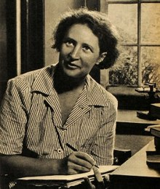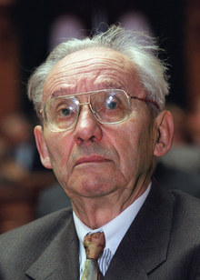

Program
About 15-25 participants

Program Structure
The Fourteenth Biennial Personalist Seminar will center around Susanne Langer and Paul Ricoeur, with separate days devoted to different aspects of their work. The first day will introduce the group to Ricoeur and Langer in their contexts. These discussions will be led by Donald Dryden (Susanne Langer) and Scott Davidson (Paul Ricoeur). The remaining days each participant will be responsible for a specific text and/or aspect, or present a paper on Langer or Ricoeur and will help lead that part of the discussion.

Proposals
Submit a title and brief (no more than one page) summary of your interest in the seminar’s subjects. Accepted projects will receive between 60 and 90 minutes for presentation and discussion of their presentation. Proposals should be sent to:
Dr. James McLachlan
jmclachla@email.wcu.edu
Due Date: May 1, 2025

Location
The seminar will be held on the campus of Western Carolina University in Cullowhee, North Carolina. Cullowhee is located approximately 50 miles west of Asheville and sits near the Great Smoky Mountains National Park, Appalachian Trail, Blue Ridge Parkway, and several national forests which make up some of the largest wilderness areas in the Eastern United States.

Lodging & Meals
Affordable on-campus accommodations are available in Harrill Hall (the site of the meeting). These are standard residence hall rooms, but all have a private bath. Linen packets are included. On-campus stays include breakfasts and lunches Monday through Friday. Dinner is on your own.
Costs
The Single occupancy rate will be $355
Double occupancy with a guest will be $600
Includes 5 Breakfasts (M-F) and 5 lunches (M-F) with one of them being a boxed lunch.
Linen packets are included, but guests must bring their own pillow.
To REGISTER for Lodging and Meals
https://continuinged.wcu.edu/portal/events/reg/participantTypeSelection.do?method=load&entityId=1232782
Off campus lodging is available in area hotels.

Conference Registration
The conference registration fee is $75 (Paid separately on arrival).

For further information about the program, contact Dr. James M. McLachlan jmclachla@email.wcu.edu or Dr. Myron Jackson, mmjackson@wcu.edu, Dept. of Philosophy and Religion, Western Carolina University, Cullowhee, NC 28723. Phone (828) 227-7262.

For questions about registration or accommodations contact Bobby Hensley, Associate Director of Continuing Education, at 828-227-7397 or email hensley@wcu.edu

Seminar Leaders

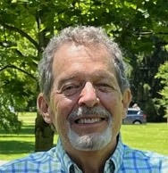

Donald Dryden received a master’s degree in the history of science from the University of Chicago and
a doctorate in philosophy from Duke University, where he is currently a Visiting Scholar in the
Department of Philosophy. His research and publications have focused on the life and work of the
American philosopher Susanne K. Langer (1895-1985) and its place in the history and philosophy of
psychology and the biological sciences. He is currently developing an interpretation of Langer’s
final work, the three volumes of Mind: An Essay on Human Feeling, from the perspective of the new
mechanism in the philosophy of science and the organicist tradition in the biological sciences.



Scott Davidson is professor of philosophy and director of the Multidisicplinary Studies program at West Virginia University. He has edited five volumes on Ricoeur's thought, including a series of companions to Ricoeur's philosophy of the will. His new book, Pathos and Praxis: An Integrated Phenomenology of Life, opens a new direction in the phenomenology of life through an engagement with the writings of Michel Henry and Paul Ricoeur.

